**Online Doctor Appointment Booking System Project**

**Introduction**

The “Online Doctor Appointment Booking System” project is a great project. This project is designed for successful execution of Online doctor appointment booking system functionality.

The basic building aim of Online doctor appointment booking system Project is to provide online facility to book an appointment with doctor and doctor can view all his appointments for the day. It is a browser-based system that is designed to store, process, retrieve and analyse information concerned with the doctor and patient along with their appointment.

This project is built to maintain all the information pertaining to book an appointment with doctor. The ultimate goal of Online doctor appointment booking system project is to provide a platform where a user/patient can book an online appointment with the doctors. It eliminates the physically visiting the hospital for an appointment and be in line for long time. Physically visiting and booking an appointment is hard for the patients or its also time-consuming process.

This system is used for maintain whole information about user/patient and doctors and appointments.

**Problem in existing system**

Existing system is that a patient has to visit the hospital just to take an appointment for the doctor. Once he gets the appointment he has to wait till the time or has to revisit the hospital as per his appointment. This is time consuming process or many problems has to face the patient as the patient may not always be in good condition. Sometime patient has to revisit the hospital if he doesn’t get the time for the day.

**Proposed system**

In the proposed system we have provided a web-based solution to the existing system. In the proposed system a patient can get online appointment by just calling or visiting the web-based application. He just needs to fills few details and in one click he will get the appointment if available.

The proposed system eliminates the visiting the hospital physically and problems of a patient. It also saves time. Once the appointment booked, he will get a particular time to meet the doctor. He has to visit the hospital just prior to that time. In this case he has not be wait much in the hospital.

This is a simple and small web-based application that may be used in hospitals for the online appointment booking.

**About the project**

There are mainly three modules in this project.

* Admin
* Patient
* Doctor

**Admin:**

Admin is the main role in the project as an admin, he can do many functionalities like adding a doctor, adding a speciality, view a doctor or edit/delete a doctor etc. Being an admin he has the full power to access the entire system.

On admin dashboard admin can perform some tasks that are as under:

* Add doctor – Admin can add a new doctor to the doctor panel. Only when admin add a doctor, the doctor can register or set the password for himself.
* Edit/Delete doctor – Admin can also view all the doctors and he can edit a doctor, delete any doctor from the doctor panel.
* Add speciality – Admin can add a new speciality.
* Edit/Delete speciality – Admi can also edit a speciality, delete a speciality from the list of the specialities.
* Logout – Once done with his work, admin can logout from his dashboard so that no other user can access the dashboard.

**Patient:**

Patient or user can book his/her appointment directly from home page. He/she can provide his/her appointment details and select the speciality and select the available doctor from the panel. Once he submits the details patient will get an appointment time for the day.

**Doctor:**

Doctor can view his appointment for the day. Each doctor will get his appointments only on his dashboard. he views the appointment details and delete the appointment once dealt with the patient.

There are some functionalities that a doctor can perform:

* View appointment – A doctor can view all his appointment for that day. He can also delete the appointments.
* Edit profile – A doctor can also update his/her profile.
* Logout – Once done with the work a doctor can logout from his dashboard so that no other user can access the dashboard.

**Languages used**

* **Front end**
  + HTML
  + CSS
  + JavaScript
* **Back-end** 
  + PHP
  + MYSQL
  + jQuery

**Software used**

1. Text editor (any)
2. Web browser (any)
3. Xampp local serve

**Schema used**

**Admins**

admins(id(int), name(varchar), email(varchar), password(varchar), mobile (big int))

**Doctors**

doctors(id(int), name(varchar), speciality(varchar), email(varchar), password(varchar), mobile(bigint));

**Specialities**

specialities(id(int), speciality(varchar));

**Appointments**

appointments(id(int), name(varchar), age(int), email(varchar), mobile(bigint), date(date), time(varchar), speciality(varchar), doctor(varchar), appointment(varchar));

**Patients**

Patients(pid(int), name(varchar), age(int), mobile(bigint), email(varchar));

**DFD Diagrma**

**Database**

**Store data**

**Fetch data**

**View profile**

**Add speciality**

**Delete appointments**

**Add doctors**

**Online Doctor Appointment Booking System Project**

**Doctors**

**Admin**

**View doctors**

**View appointments**

**View Speciality**

**Edit profile**

**Book appointment**

**Get appointments**

**Patients**

**ER Diagra**

**specialty**

**name**

**email**

**id**

**name**

**id**

**email**

**Manage**

**Doctors**

**mobile**

**Admins**

**password**

**password**

**mobile**

**HAS**

**takes**

**Manage**

**name**

**id**

**date**

**id**

**Specialties**

**age**

**time**

**Appointments**

**specialty**

**specialty**

**email**

**mobile**

**doctor**

**Books**

**pid**

**name**

**Patients**

**age**

**email**

**mobile**

**Summary and Conclusion**

With the theoretical inclination of our syllabus, it becomes very essential to take the utmost advantage of any opportunity of gaining practical experience that comes along. The building blocks of this Major Project “Online Doctor Appointment Booking System” was one of these opportunities. It gave us the requisite practical knowledge to supplement already taught theoretical concepts thus making us more competent as a computer engineer. The project from a personal point of view also helped us in understanding many aspects.

The project also provided us the opportunity of interacting with our teacher and to gain from their best experience.

**Login IDs**

**Admin login details –**

Email id – admin@gmail.com

Password – admin@123

**Doctor login details –**

Email id – hemlata@gmail.com

Password – hem@123

**Some screenshots from the project –**

**Appointment Booking Page**

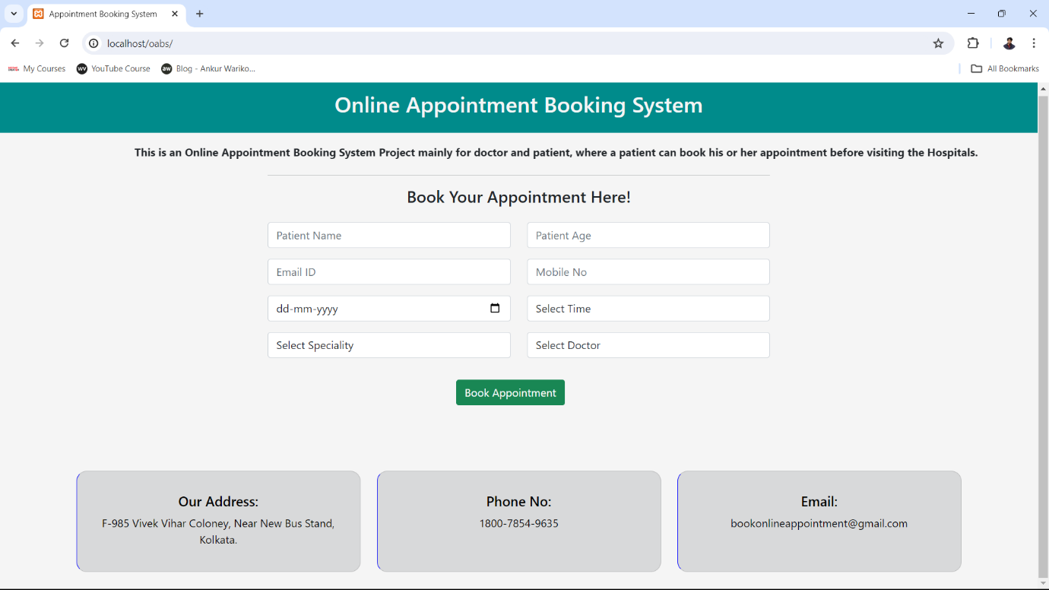

**Doctor Login Page**

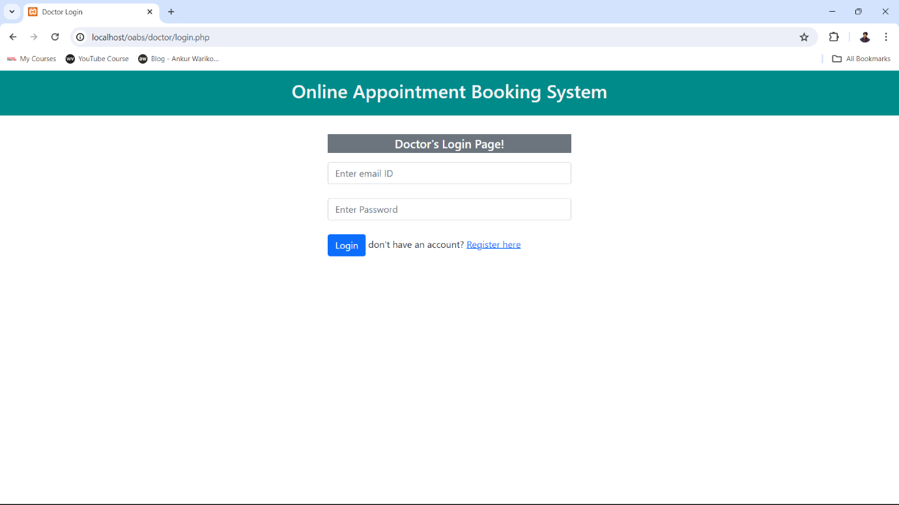

**Doctor Dashboard Page**

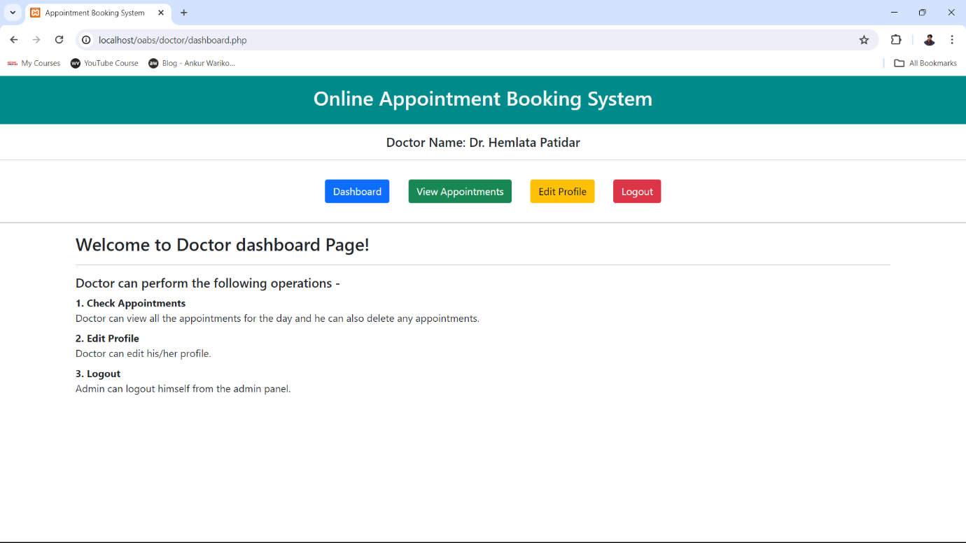

**Edit Doctor Profile Page**

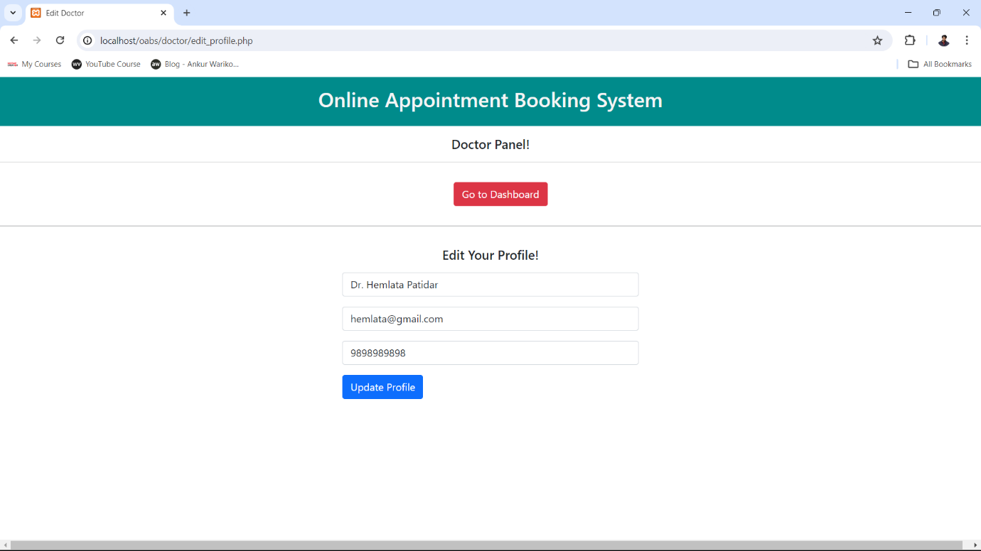

**View Appointments Page**

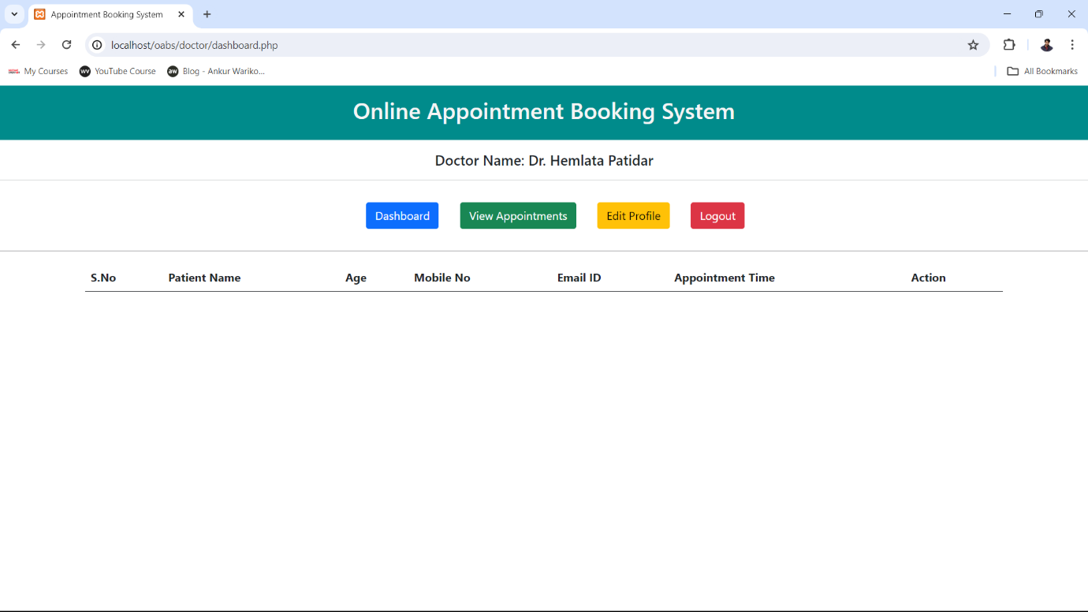

**Admin Dashboard Page**



**Add Doctor Page**

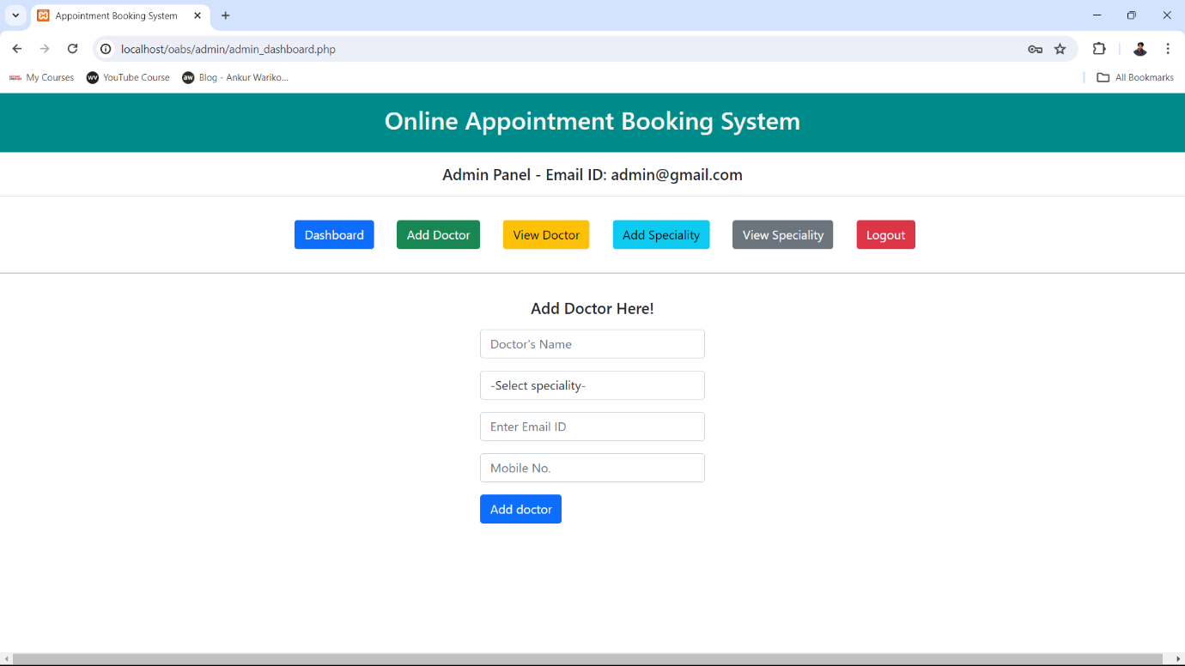

**View Doctor Page**

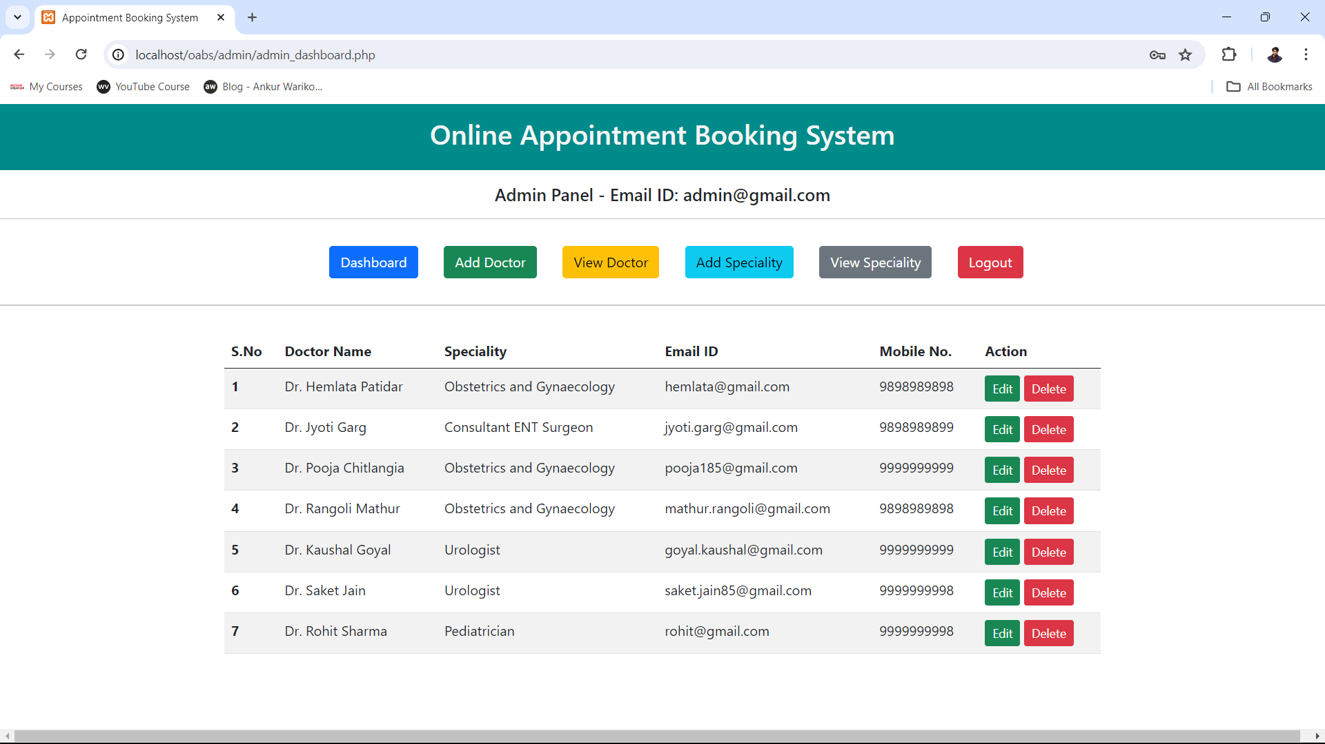

**Add Speciality Page**

